Investigation
DNA Profiling Biological Science 3B 2015

NAME: ______________________________ /25 MARKS

Biotechnologists use a variety of laboratory techniques which enable the comparison of DNA from different individual organisms.

In class you carried out the process of gel electrophoresis. Answer the following questions regarding that practical.

1. Micropipettes were used in the practical. What was the volume of the sample you used?
________________________________ (1 mark)
2. How was contamination prevented in the sampling procedure? (1 mark)

_______________________________________________________________________

_______________________________________________________________________

3. Why does the sample move through the gel? (2 marks)

_______________________________________________________________________

_______________________________________________________________________
4. What two factors control the speed of its movement? (2 marks)

_______________________________________________________________________

_______________________________________________________________________
5. Why do the segments of the sample separate? (2 marks)

_______________________________________________________________________

_______________________________________________________________________
_______________________________________________________________________

_______________________________________________________________________

6. How would you identify two identical segments in different samples? (1 mark)

_______________________________________________________________________

_______________________________________________________________________

7. What is the purpose of the buffer solution? (1 mark)

_______________________________________________________________________

_______________________________________________________________________

8. What would be the disadvantages of running the gel for too long or to short a time?
(2 marks)

_______________________________________________________________________

_______________________________________________________________________
_______________________________________________________________________

_______________________________________________________________________
9. What two other biotechnological processes would have to be carried out before you could use the DNA for gel electrophoresis ? Explain why each one is necessary. (4 marks)

_______________________________________________________________________
More lines
_______________________________________________________________________
_______________________________________________________________________

_______________________________________________________________________
_______________________________________________________________________

10. Apart from sampling procedures, why can we not use real DNA in the classroom procedure? (2 marks)

_______________________________________________________________________

_______________________________________________________________________

11. Explain three sources of error which could occur during this procedure. (3 marks)

_______________________________________________________________________

_______________________________________________________________________
_______________________________________________________________________

_______________________________________________________________________
_______________________________________________________________________

_______________________________________________________________________

12. The Scenario:
For three years a team of researchers have been watching three different Humpback whale pods off the coast of Exmouth in Western Australia. They are especially interested in the genetic diversity of these whales. As the numbers of humpback whales are decreasing, determining the genetic diversity of these populations is increasingly more important. In particular, this team is interested in which calves belong to a particular mating pair of whales. Using second hand data you are going to help them figure this out!

Problem: Which of the three calves does not belong to the mating pair of whales shown? Explain your answer.

 | Individuals tested | DNA sample
 | Father | 1
 | Mother | 2
 | Calf A | 3
 | Calf B | 4
 | Calf C | 5

Analyzing the DNA data: Sample result

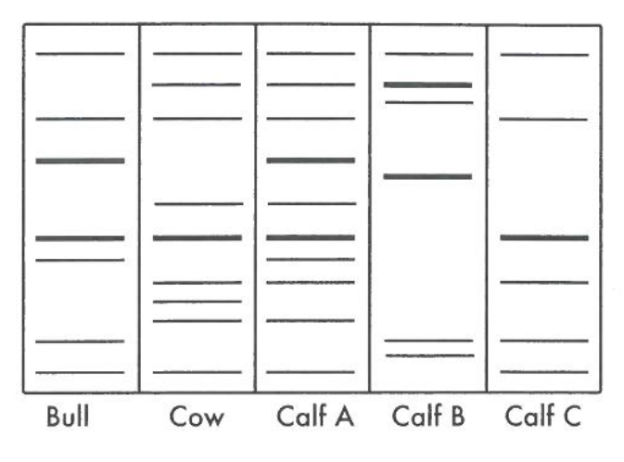

Are any of the calves offspring of the two parents? Explain fully with reference to the sample result. (4 marks)

_______________________________________________________________________

_______________________________________________________________________
_______________________________________________________________________

_______________________________________________________________________
_______________________________________________________________________

_______________________________________________________________________

_______________________________________________________________________

_______________________________________________________________________

